Friday, Aug 24 & Saturday Aug 25, 2018
Panhandle Trail – Collier Township
MUSIC, FOOD, SCIENCE DEMO, GAMES, RAFFLES, CAMPFIRE, BEER and DUCKY RACE - FUN FOR ALL AGES
Friday (5:15 – 11:00PM)
Bill Ali Band (Classic Rock) 9pm and
Mad Mike’s Blues Revue (R & B) 7:25pm
With Special Musical Guests:
5:15pm Jenny and the Jags (Rock)
6:00pm Mr. Science (Event Tent)
6:15pm BADDADZ (Classic Rock)

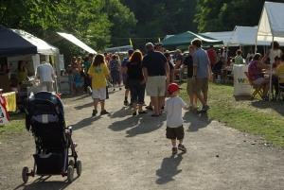

Donations Benefit the Collier Friends of the Panhandle Trail

Thanks to our Vendors and Sponsors

Carnegie-Collier Rotary
Chickis Cool Treats
Cub Pack 860
CV Wrestling Team
D&R Kettle Korn
Dylan's Quest Cotton Candy
Gaitens, Tucceri & Nicholas, PC
Rennerdale Corner Store

Saturday (3:00PM–11:00PM)
NOMaD (Country) 9pm
and
Bindley Hardware Co (Americana) 7pm

With Special Musical Guests:
3:00pm Dead Sin (Classic Rock)
3:30pm Mr. Science (Event Tent)
4:10pm The Grid (Classic Rock)
5:30pm Collissions (Classic Rock)
7:30pm Flag Ceremony
7:40pm Rubber Ducky Race

Family Fun Zone (all day)
Games & Crafts (all day)

Free Admission & Parking;
Bring Friends and Family
No Outside Alcohol

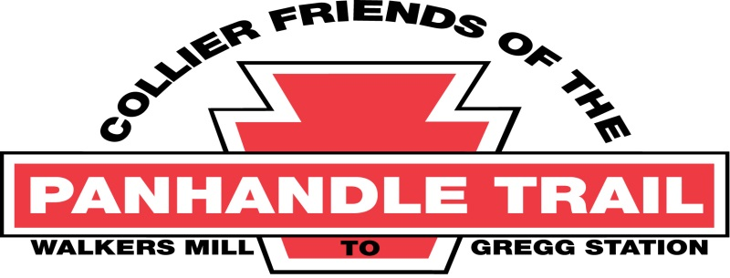
www.PanhandleTrail.org

